CASE FILE 02
Rally Paddle Co.
Product line: pickleball paddles
Rally Paddle Co. makes pickleball paddles in a small shop in Schaumburg. Pickleball is exploding, and Rally wants a lineup that covers brand-new players all the way to tournament regulars.
Your job: Build a lineup of three versions, one for each segment below. For every version, choose its features and set its price. Your goal is the most total profit across all three.
THE MARKET: THREE SEGMENTS
Rally Paddle Co. surveyed people in the Chicago area. The survey split them into three groups. Read the profiles, then give each segment a name.
SEGMENT A  11,000 potential customers | SEGMENT B  3,500 potential customers | SEGMENT C  7,000 potential customers
- Ages 30 to 65, picked up the sport in the last year  - Plays once a week at park district courts  - Often buying for a spouse or kids too  “I just don't want to look silly the first time I play.” | - Plays 4 or more times a week, enters tournaments  - Watches pro matches and gear reviews online  - Replaces their paddle about once a year  “Spin wins points. Give me spin.” | - Ages 14 to 22, plays with friends and in gym class  - Posts court videos on social media  - Cares how the paddle looks as much as how it plays  “If it looks sick, I'll use it.”
Our name for them: | Our name for them: | Our name for them:
PRODUCT BASICS
Base cost of every version | $12 per paddle, before any features are added
Price options | $25 $40 $60 $90 $130 $180 (each version must use one of these prices)
WARM-UP: READ THE DATA FIRST
1. Which segment has the most must-have features (60% or higher)? How many does it have?

2. What is the most expensive feature on the menu? Which segment, if any, says it is a must-have?

3. What is the lowest price at which fewer than half of Segment B would buy?

4. If Rally Paddle Co. sold a version with a Fit of 100% to Segment A at $40, how many people would buy it?

SURVEY RESULTS: WHAT EACH SEGMENT REQUIRES
Question asked: “Which of these would a pickleball paddle need to have before you would buy it?”
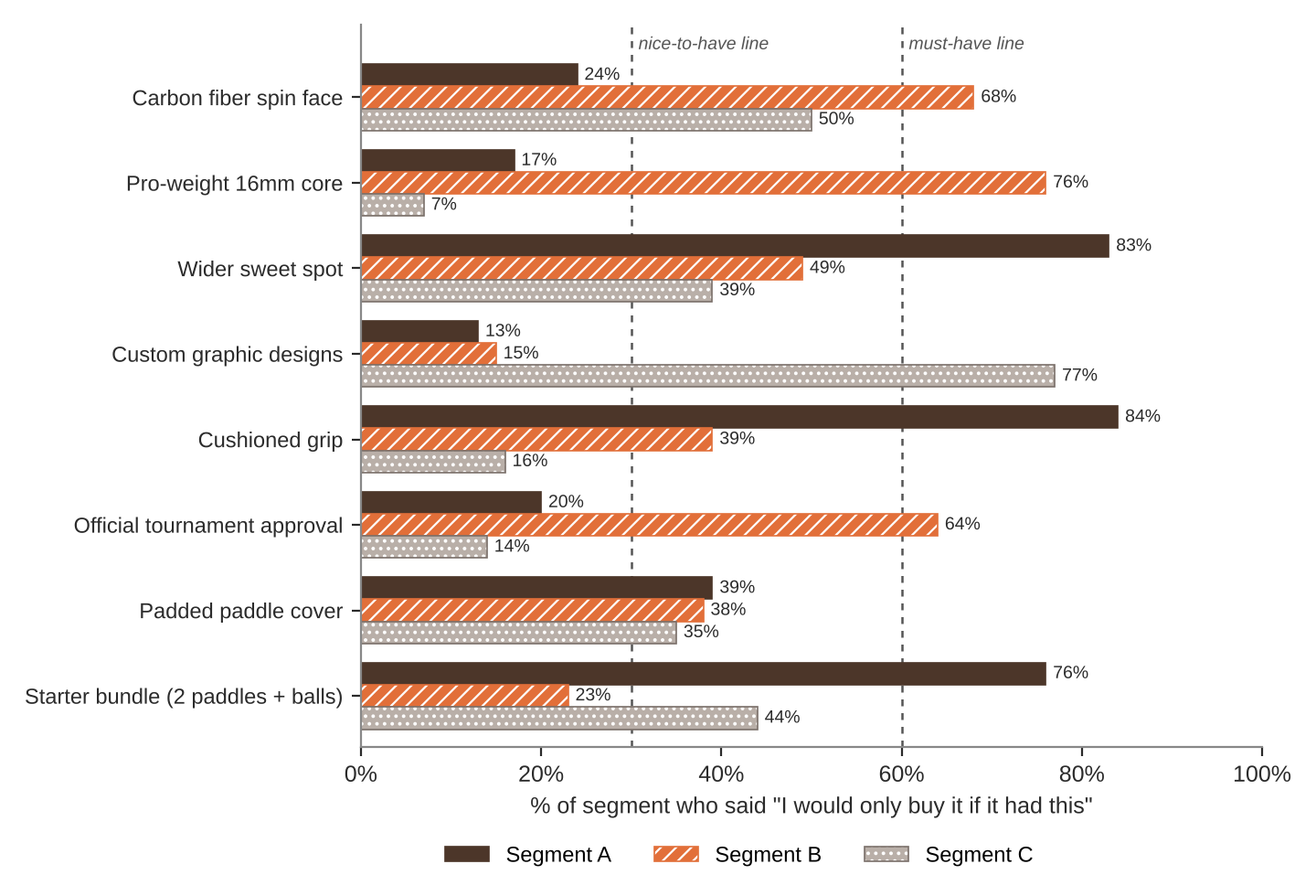
FEATURE MENU
Every feature you add raises your cost per paddle. Add a feature to any version you want.
Feature | What it is | Cost to add
Carbon fiber spin face | Gritty surface that grabs the ball | $16
Pro-weight 16mm core | More power and control for advanced players | $9
Wider sweet spot | More forgiving on off-center hits | $5
Custom graphic designs | Bold art and colorways | $4
Cushioned grip | Softer on the hands | $2
Official tournament approval | Legal for sanctioned tournaments | $6
Padded paddle cover | Protects the face in a bag | $3
Starter bundle (2 paddles + balls) | Everything needed to play today | $10
SURVEY RESULTS: WHAT EACH SEGMENT WILL PAY
Question asked: “If it had everything you need, would you buy it at this price?”
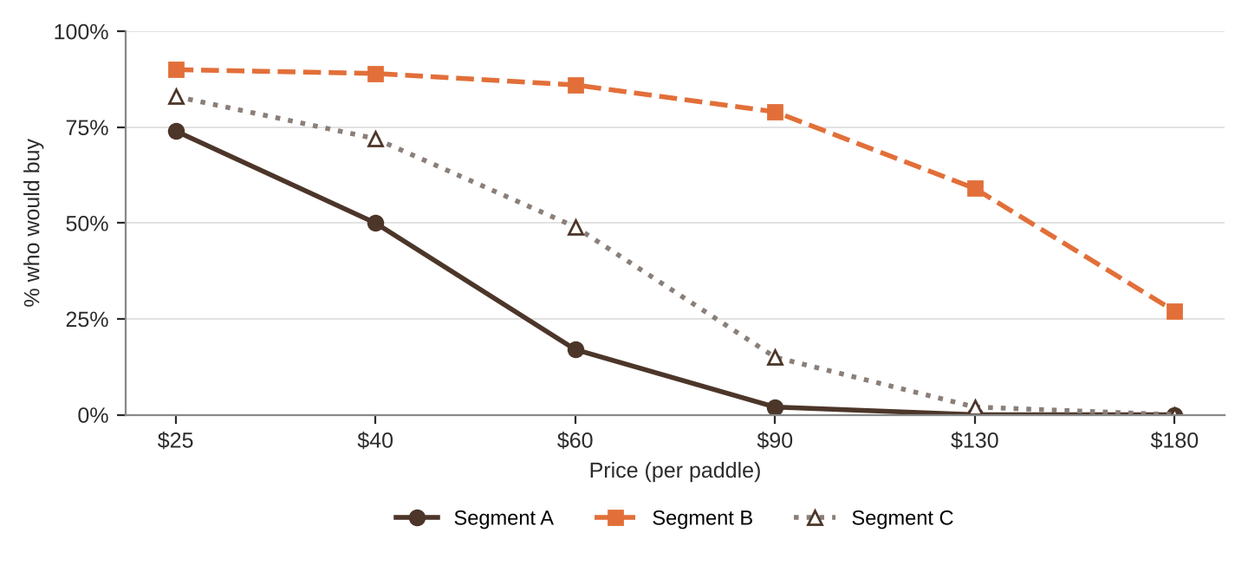
% of each segment who would buy at each price
Price | $25 | $40 | $60 | $90 | $130 | $180
Segment A | 74% | 50% | 17% | 2% | 0% | 0%
Segment B | 90% | 89% | 86% | 79% | 59% | 27%
Segment C | 83% | 72% | 49% | 15% | 2% | 0%
QUICK RULES
Must-have | A feature that 60% or more of a segment requires. Leave one out and that segment's buyers are cut in half. Leave two out and they're cut in half again.
Nice-to-have | A feature that 30% to 59% of a segment requires. Each one you include adds 5% to Fit.
Under 30% | That segment doesn't care. It adds cost and nothing else.
Fit | Start at 100%. Add 5% for each nice-to-have included. Then cut in half for each must-have left out.
Buyers | Segment size × % who would buy at your price × Fit. Round to a whole number.
Profit | Buyers × (Price − Unit cost). Unit cost = base cost + cost of every feature you added.

